

PREDICTIVE ANALYTICS LAB

LAB FILE SUBMITTED BY: SUBMITTED TO:

Miss. Priyanka Singh

NAME:AADYA SRIVASTAVA SAP ID: 500105682

ROLL NO: R2142220003

BATCH: 5(AI-ML(NH))

# LAB EXERCISE -5

Descriptive Statistics of data:

* 1. Measure of Central Tendency: Mean, Geometric mean, Harmonic mean, Mode, Median

# Code:

# Selecting relevant numerical columns for analysis

numeric_columns = ['age', 'height_cm', 'weight_kg', 'body fat_%', 'diastolic', 'systolic',

'gripForce', 'sit and bend forward_cm', 'sit-ups counts', 'broad jump_cm']

# Mean

mean_values = df[numeric_columns].mean()

# Geometric Mean (ignoring negative and zero values as they are not valid for geometric mean)

geom_mean_values = df[numeric_columns].apply(lambda x: stats.gmean(x[x > 0]))

# Harmonic Mean (ignoring negative and zero values)

harmonic_mean_values = df[numeric_columns].apply(lambda x: stats.hmean(x[x > 0]))

# Mode mode_values =

df[numeric_columns].mode().iloc[0]

# Median

median_values = df[numeric_columns].median()

# Central Tendency Results central_tendency = pd.DataFrame({

'Mean': mean_values,

'Geometric Mean': geom_mean_values, 'Harmonic Mean': harmonic_mean_values, 'Mode': mode_values,

'Median': median_values

})

print("Central Tendency:\n", central_tendency)

# Output:

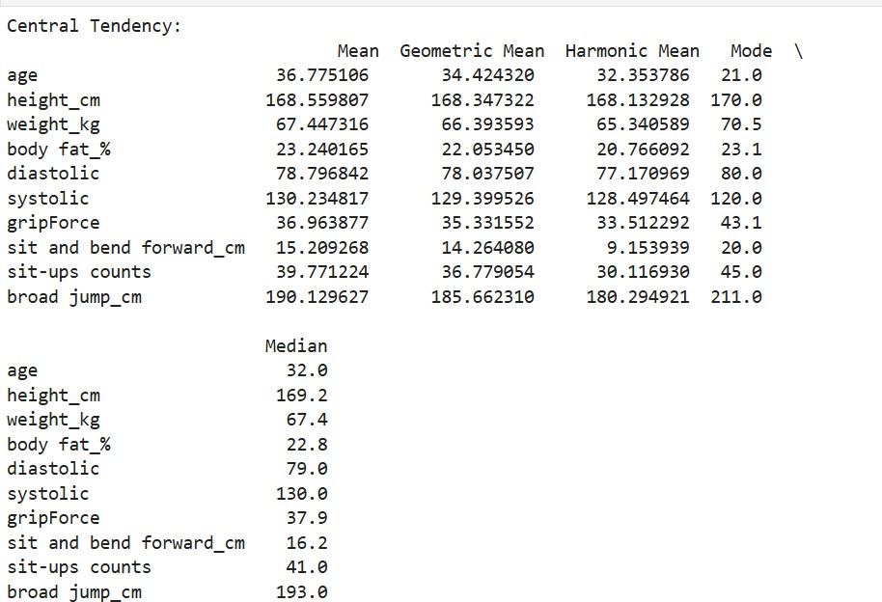

* 1. Measure of Dispersion: Variance, Standard deviation, Shape of Data (Symmetric, Skewness), Inter Quartile Range (IQR) / percentiles, Range, Mean Absolute Deviation(MAD)

# Code:

# Mean Absolute Deviation (MAD)

mad_values = df[numeric_columns].apply(lambda x: np.mean(np.abs(x - np.mean(x))))

# Dispersion Results dispersion = pd.DataFrame({

'Variance': variance_values, 'Standard Deviation': std_dev_values, 'Skewness': skewness_values,

'IQR': iqr_values, 'Range': range_values, 'MAD': mad_values

})

print("Dispersion:\n", dispersion)

# Output:

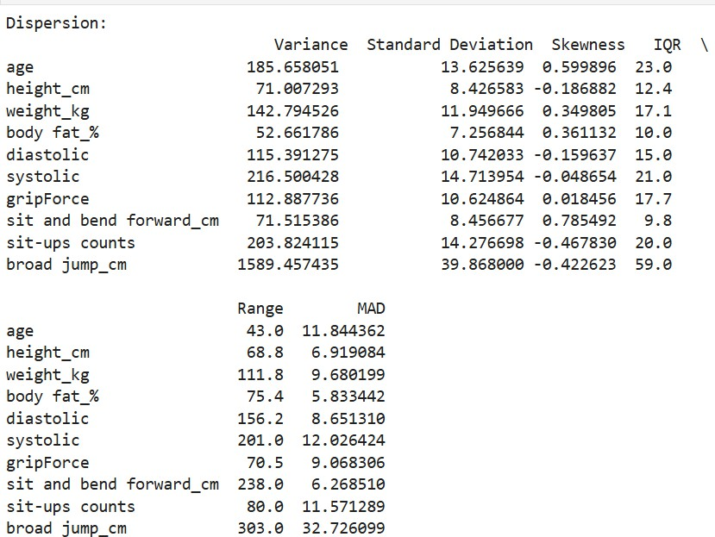

* 1. Correlation between features.

# Code:

# Correlation Matrix (default is Pearson correlation)

correlation_matrix = df[numeric_columns].corr() print("Correlation Matrix:\n", correlation_matrix)

# Output:

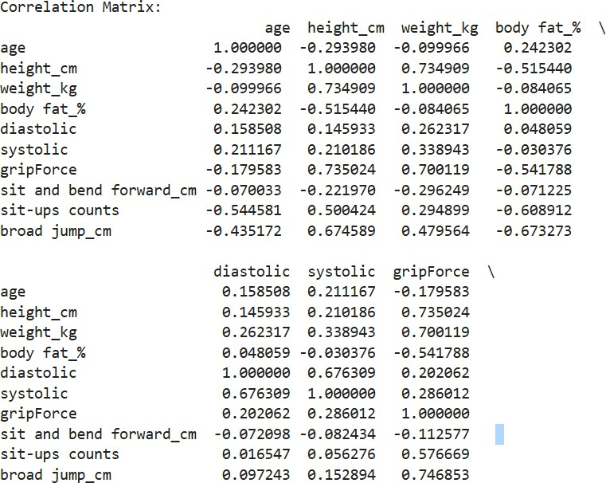

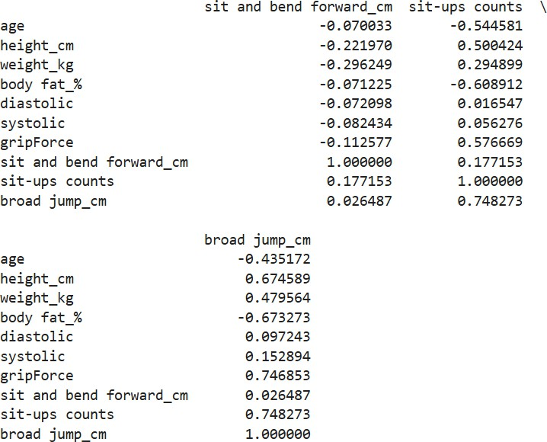

1.4. Visualizing Data Distribution: Boxplot, Histograms, Density plots, Scatterplot, Bar chart

# Code:

**Boxplot:**

# Boxplot for each numerical feature sns.boxplot(data=df[numeric_columns]) plt.title('Boxplot of Numerical Features') plt.xticks(rotation=90)

plt.show()

# Output:

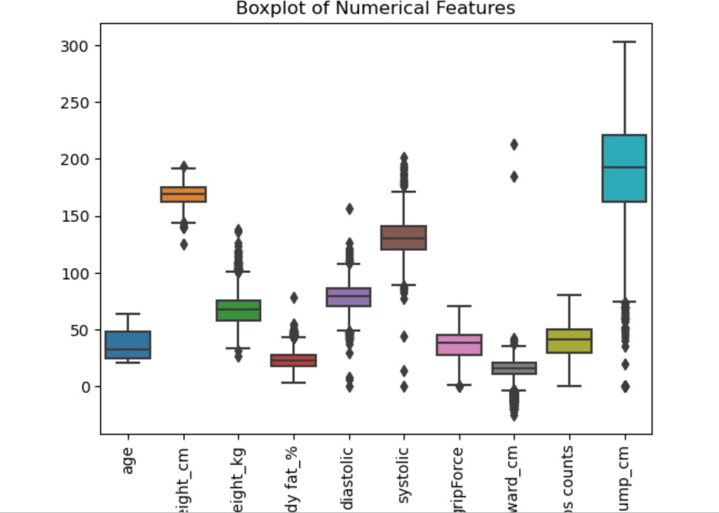

**Histograms**

# Histogram for each feature

df[numeric_columns].hist(figsize=(10, 8), bins=10)

plt.suptitle('Histograms of Numerical Features') plt.show()

# Output:

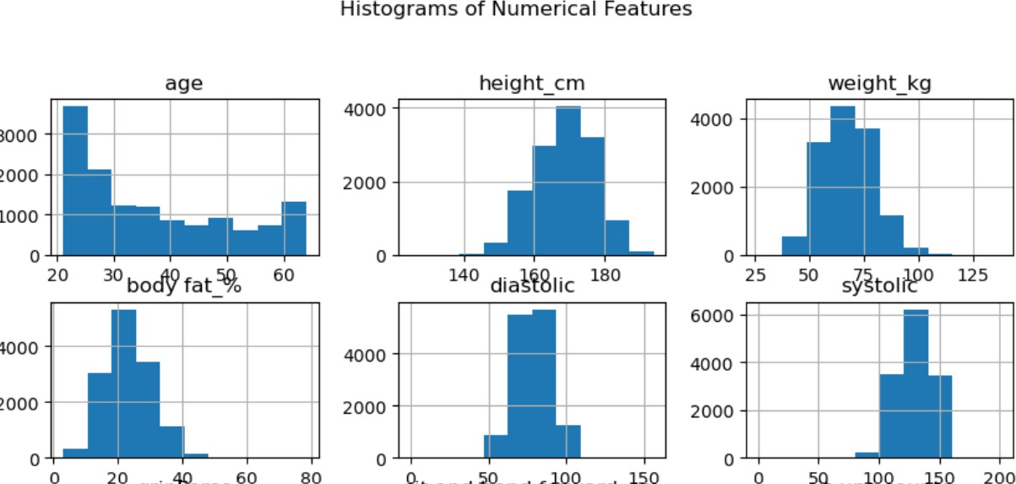

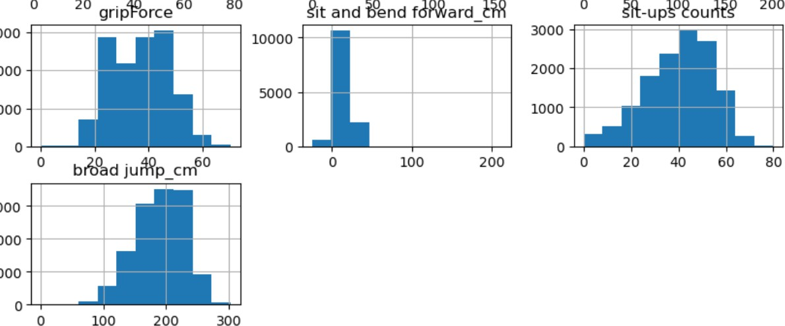

**Density Plots:**

# Density Plot for each feature

df[numeric_columns].plot(kind='density', subplots=True, layout=(4,3), figsize=(12,10), sharex=False)

plt.suptitle('Density Plots of Numerical Features') plt.show()

# Output:

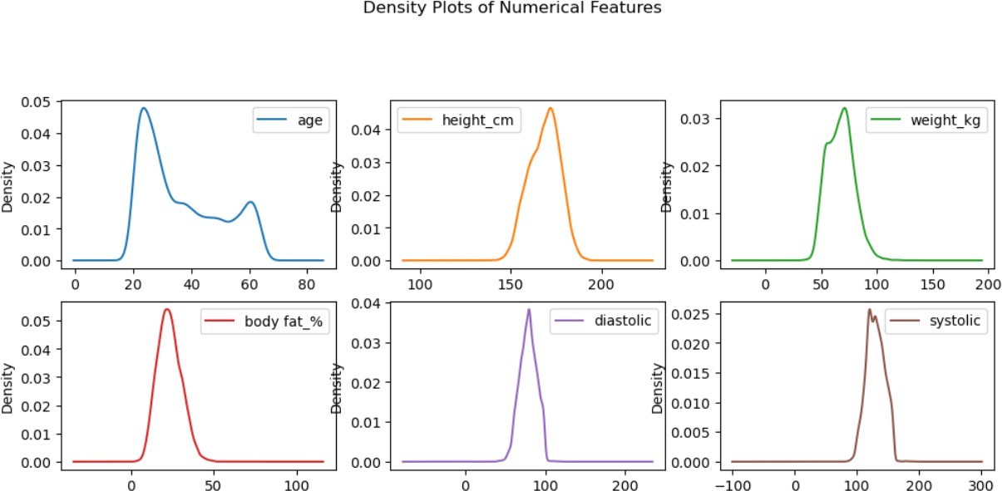

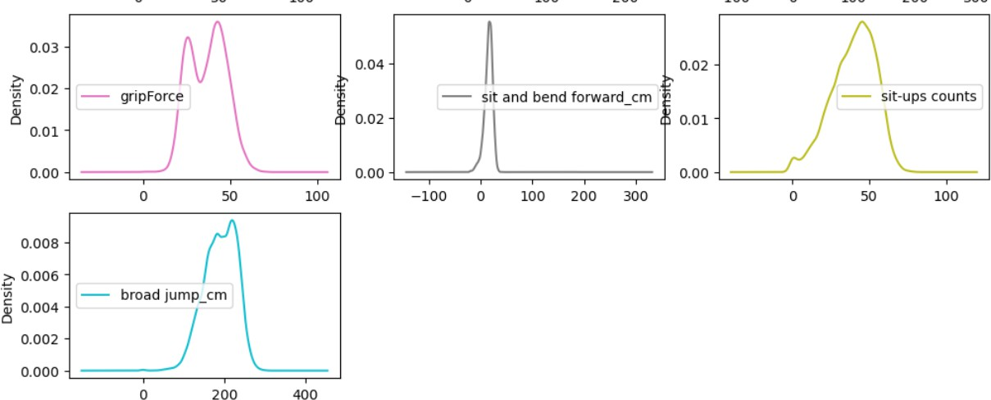

**Scatterplots:**

# Scatterplot between 'height_cm' and 'weight_kg'

sns.scatterplot(x='height_cm', y='weight_kg', data=df)

plt.title('Scatterplot between Height and Weight') plt.show()

# Output:

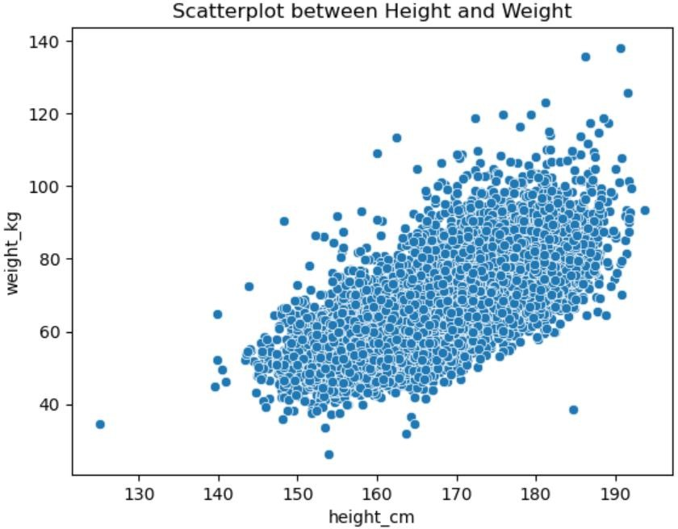

**Bar Chart:**

# Bar chart of Value Counts for 'age' (or any other column)

df['age'].value_counts().plot(kind='bar') plt.title('Bar Chart of Age Distribution') plt.xlabel('Age')

plt.ylabel('Count') plt.show()

**Output:**

